Benefits of Going Paperless in Retail

BY:Mehul Pakhare and Neeraj Patil

20302F0019 &20302F0018

Introduction

In today's world, one of the biggest issues faces by all of us is global warming. Global warming refers to an increase in average global temperatures. The main cause of global warming is increasing in the concentration of greenhouse gases (GHGs) in the atmosphere and fewer trees to reduce it. It all could be stopped if we reduce greenhouse and plant more trees i.e going paperless and the best way to do it is to make an entire industry/business paperless. Also, Imagine organizing and using a paper-based management system. The study carried out by the McKinsey Global Institute (MGI) in 2012 found that: 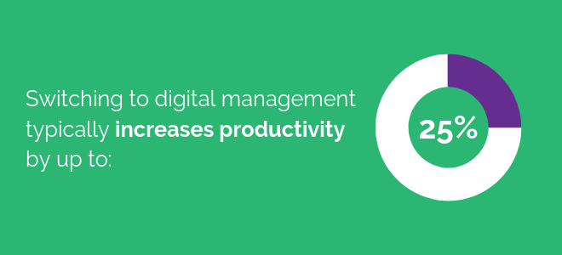

This boost is provided by the inherent speed and efficiency benefits of digital communications when compared with a traditional paper approach. A paper-based approach means slower processes, more administrative resources and a higher risk of inefficiency - documents lost, handwritten notes being misread and paperwork incomplete, thus losing its reputation when mistakes are done. Compliance is a challenging area to control when paper-based management methods are being used. There’s a dangerous tendency for compliance measures to be viewed as being needless paperwork chores. It’s an area where digital management methods have a major advantage - allowing checks and notifications to be automatically integrated into the everyday workflow. Any reliance on paper is liable to increase the amount of travel that’s required for mobile workers. To access job information, employees will typically have to pick up paperwork from an office or depot. And once a job’s finished, they need to drop off any information that has been collected during the day. When you multiply these journeys across an organization and throughout the year, you have significant additional costs that can be avoided when using digital forms of business communication. Typically, a field service operation will require at least one job-sheet to be printed out for each scheduled task. On top of this, there are multiple forms, documents, worksheets, certificates, plans and diagrams that may be needed for a particular job. The costs incurred aren’t just for the paper itself, it’s for the whole infrastructure that’s required to handle printed information - postage, stationery, printers, photocopiers and ink cartridges. And the more information that’s printed, the more space a company requires to securely store all of this information. This includes the administrative time and resources required to manually handle large amounts of paperwork.

It is estimated that a switch to digital management methods saves around £5 per job for a mobile working operation. For a medium-sized field service business, delivering around 50 services each day, this would deliver annual savings of £62,500.

Review of Literature:

According to the national filing survey (done by Kardex Systems, UK) over 1 million pounds are wasted on a daily basis to find lost files. Office filing staff in the UK earn roughly £8-£9 per hour and the average cost for locating each file is approximately £10. The managing director of Kardex claims that “6 percent of the UK’s 2.1 million businesses admit to losing at least one file per day – that adds up to120,000 lost files. By this estimate, poor filing practices are costing UK businesses £1.2million every working day or more than £240 million a year”.

The survey goes on to state that 55 percent of the missing files are misfiled, 48percent are on the desks of other members of staff, approximately 13 percent can be found on the boss’ desk. The staggering reality though, according to the surveyors, is that 2 percent of the files lost are never found. For businesses with very sensitive material this can be very tragic situation indeed. Too much paper in any organization leads to confusion and waste. Companies cannot afford to be complacent and rely on the outdated method of using filing cabinets for storing important information. Thousands of dollars are wasted in companies all over the world to store information the old fashioned way and at the same time efficiency and profitability are greatly compromised .

Sellen and Harper make a case for paper in the Myth of the Paperless Office (2003). They argue that the world wide web has only increased the amount of printing done by users and according to the duo, paper consumption has increased by approximately 40percent since the introduction of electronic mail. The new technologies have failed to have the predicted effect on paper consumption. Instead of getting rid of paper, new technologies either increase or shift the ways in which paper is used. Banning the use of filing cabinets will see persons finding new and innovative ways to store paper.

More than half of the Office workers currently use electronic files daily. In fact, a total of 85 percent felt that way. Surprisingly, most of the workers claimed not to have any difficulties locating important paper files. Only 30 percent had any difficulty at all locating paper files on a daily basis; 65 percent of the respondents saved approximately 90 percent of their work electronically on a daily basis. Here is a pie chart showing the results of this survey

IF we could make more people use electronic means of storing data, it could lead to decreased business cost and benefit the environment. In terms of shareability electronic documents are also very easy to share rather then physical documents. Moreover digital documents have less chances of getting lost and are easier to store and manage.

Reference

* An analysis of the feasibility of a paperless environment - The case of the Mona School of Business BY: Mardene Rosalee Carr